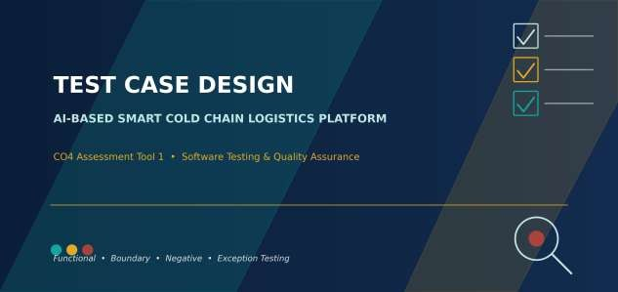

Student Name | Manisha M
Register Number | 192424130
Programme | B.Tech — Artificial Intelligence & Data Science
Institution | Saveetha Institute of Medical and Technical Sciences (SIMATS Engineering)
Assessment | CO4 Assessment Tool 1 — Test Case Design Assignment
Assigned System | AI-Based Smart Cold Chain Logistics Monitoring and Optimization Platform

Requirements Identification

Before scenarios or test cases can be written, the requirements of the AI-Based Smart Cold Chain Logistics Platform were reviewed and split into functional requirements (what the system must do) and non-functional requirements (how well it must do it). Both types drive different kinds of test cases below.

Functional Requirements (FR)

ID | Requirement
FR-1 | System shall record temperature and humidity readings from IoT sensors at regular intervals.
FR-2 | System shall track and update shipment GPS location in real time.
FR-3 | System shall predict refrigeration equipment failure using historical telemetry.
FR-4 | System shall recommend an optimized delivery route based on distance, traffic and risk.
FR-5 | System shall generate an automated alert when a sensor reading breaches a safe threshold.
FR-6 | System shall authenticate users before granting access to the dashboard.

Non-Functional Requirements (NFR)

ID | Requirement
NFR-1 | Alerts must be delivered within 5 seconds of a threshold breach (performance).
NFR-2 | The dashboard must remain usable with at least 500 concurrent shipments tracked (scalability).
NFR-3 | Sensor and login data must be transmitted over encrypted channels (security).
NFR-4 | The system must remain operational if a single microservice restarts (reliability).
NFR-5 | Dashboard screens must be understandable to a non-technical logistics operator (usability).

Test Scenario Identification

Each requirement was expanded into one or more concrete test scenarios: realistic situations a tester can walk through end to end. The process used to move from a raw requirement to an executable test case is summarised below.
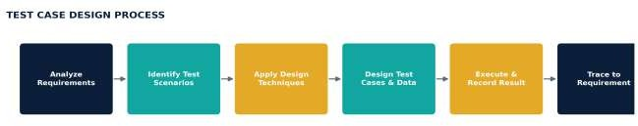

Figure 2.1 — Process followed to derive test cases from requirements

Identified Test Scenarios

Scenario ID | Test Scenario | Related Requirement
TS-01 | Verify sensor readings within the safe range are logged without triggering an alert. | FR-1, NFR-1
TS-02 | Verify readings at and beyond the safe temperature boundary are handled correctly. | FR-1, FR-5
TS-03 | Verify GPS location updates reflect the shipment's real-time position. | FR-2
TS-04 | Verify the system behaves correctly when GPS signal is lost mid-transit. | FR-2, NFR-4
TS-05 | Verify the failure-prediction model flags a high-risk reefer unit before breakdown. | FR-3
TS-06 | Verify prediction behaviour when sensor input data is missing or corrupted. | FR-3
TS-07 | Verify the route optimizer proposes the lowest-risk route for a valid shipment. | FR-4
TS-08 | Verify alert notifications are generated and delivered within the required time. | FR-5, NFR-1
TS-09 | Verify only authorized users can log in and reach the dashboard. | FR-6, NFR-3
TS-10 | Verify the system remains available when one microservice is restarted. | NFR-4

Test Design Techniques Applied

Four complementary test design techniques were applied so that the test suite catches errors a single technique would miss on its own.

Equivalence Partitioning — Temperature Input
The temperature input field was split into equivalence classes; one representative value from each class is enough to test that class.

Class | Range / Condition | Representative Value | Expected Handling
Valid | 2°C to 8°C (inclusive) | 5°C | Accepted, logged as normal
Invalid — too low | < 2°C | -5°C | Rejected / alert triggered
Invalid — too high | > 8°C | 15°C | Rejected / alert triggered
Invalid — non-numeric | Text or null sensor payload | "ERR" / null | Input rejected, exception logged

Boundary Value Analysis — Temperature Thresholds

BVA focuses specifically on the edges of the valid range identified above, since defects cluster at boundaries far more often than in the middle of a range.
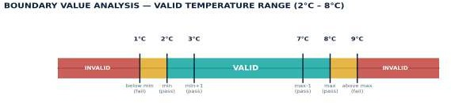

Figure 3.1 — Boundary values tested around the 2°C–8°C safe range

Decision Table — Alert Generation Logic
Alert generation depends on the combination of temperature status and humidity status, so a decision table captures every combination cleanly.

Rule | Temp In Range? | Humidity In Range? | Door Open? | Action
R1 | Yes | Yes | No | No alert — log normal
R2 | No | Yes | No | Temperature alert
R3 | Yes | No | No | Humidity alert
R4 | No | No | No | Critical combined alert
R5 | Yes | Yes | Yes | Door-open warning
R6 | No | — | Yes | Critical alert + door warning

State Transition Testing — Shipment Lifecycle
Because a shipment moves through a well-defined sequence of states, state transition testing verifies both valid transitions (e.g. In Transit → Delivered) and that invalid transitions (e.g. Delivered → In Transit) are correctly rejected.

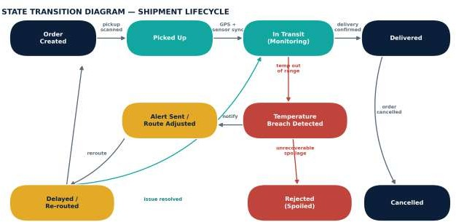

Figure 3.2 — Valid shipment states and transitions used to design state-based test cases

Detailed Test Cases

Test cases below cover normal, boundary, invalid, and exceptional conditions across all six functional modules, using the techniques introduced in Section 3. Actual results reflect a first execution pass against a staging build; items marked Fail* indicate defects logged for developer follow-up.

Module A — Temperature & Humidity Monitoring

ID | Scenario | Steps | Test Data | Expected Result | Actual Result | Status
TC-01 | Normal reading within safe range | 1. Send sensor payload 2. Observe dashboard log | temp=5°C, hum=55% | Reading logged as Normal; no alert | Logged as Normal; no alert | Pass
TC-02 | Boundary — minimum valid temperature | 1. Send reading at lower limit | temp=2°C | Accepted as valid (pass boundary) | Accepted as valid | Pass
TC-03 | Boundary — just below minimum | 1. Send reading just under limit | temp=1°C | Rejected / alert triggered | Alert triggered correctly | Pass
TC-04 | Boundary — maximum valid temperature | 1. Send reading at upper limit | temp=8°C | Accepted as valid (pass boundary) | Accepted as valid | Pass
TC-05 | Boundary — just above maximum | 1. Send reading just over limit | temp=9°C | Rejected / alert triggered | Alert triggered correctly | Pass
TC-06 | Invalid — non-numeric sensor payload | 1. Send malformed payload 2. Check error handling | temp="ERR" | Input rejected; exception logged, no crash | System crashed silently, no log entry | Fail*
TC-07 | Exceptional — sensor disconnected mid-transit | 1. Simulate sensor timeout 2. Wait 60s | no signal for 60s | "Sensor Offline" warning raised | Warning raised as expected | Pass

Module B — GPS Tracking

ID | Scenario | Steps | Test Data | Expected Result | Actual Result | Status
TC-08 | Normal GPS location update | 1. Send GPS coordinates 2. View map | lat=13.08, lng=80.27 | Marker updates to new position | Marker updated correctly | Pass
TC-09 | Boundary — coordinate at geofence edge | 1. Send location exactly on zone border | boundary lat/lng | Classified as inside delivery zone | Classified as inside zone | Pass
TC-10 | Invalid GPS coordinates | 1. Send out-of-range coordinates | lat=999, lng=999 | Input rejected with validation error | Rejected with validation error | Pass
TC-11 | Exceptional — GPS signal lost in transit | 1. Simulate signal loss 2. Wait for timeout | no GPS fix for 5 min | "Location Unavailable" shown, last known position retained | Last known position retained correctly | Pass

Module C — AI Failure Prediction

ID | Scenario | Steps | Test Data | Expected Result | Actual Result | Status
TC-12 | Normal prediction with sufficient history | 1. Feed 30 days telemetry 2. Request prediction | 30-day dataset | Risk score returned (0–1) with confidence | Risk score 0.31 returned correctly | Pass
TC-13 | Boundary — risk score exactly at alert threshold | 1. Feed data producing score = 0.70 | score=0.70 (threshold) | Classified as "High Risk" (inclusive) | Classified as High Risk | Pass
TC-14 | Invalid — corrupted telemetry input | 1. Feed malformed/partial dataset | missing 80% of fields | Graceful fallback / "insufficient data" response | Model returned NaN with no fallback | Fail*
TC-15 | Exceptional — prediction service unavailable | 1. Stop AI/ML container 2. Request prediction | service down | Dashboard shows fallback message, no crash | Fallback message shown, no crash | Pass

Module D — Route Optimizer

ID | Scenario | Steps | Test Data | Expected Result | Actual Result | Status
TC-16 | Normal optimal route generated | 1. Enter valid origin & destination | valid coordinates | Lowest-risk route returned with ETA | Route and ETA returned correctly | Pass
TC-17 | Invalid destination coordinates | 1. Enter out-of-service-area destination | destination outside coverage | "No serviceable route" message shown | Message shown correctly | Pass
TC-18 | Exceptional — no valid route available | 1. Block all routes in test map data | all routes blocked | System reports unavailability, does not hang | Request timed out with no response | Fail*

Module E — Automated Alerts

ID | Scenario | Steps | Test Data | Expected Result | Actual Result | Status
TC-19 | Normal alert on threshold breach | 1. Trigger out-of-range reading 2. Time delivery | temp=15°C | Alert delivered within 5 seconds (NFR-1) | Delivered in 3.2 seconds | Pass
TC-20 | Boundary — reading exactly at threshold | 1. Send reading exactly at limit | temp=8°C | No alert (boundary is valid, inclusive) | No alert raised | Pass
TC-21 | Invalid — duplicate rapid-fire readings | 1. Send 20 breach readings in 2 seconds | 20x temp=15°C | Single de-duplicated alert, not 20 alerts | 20 separate alerts sent (spam) | Fail*
TC-22 | Exceptional —  notification service down | 1. Stop notification service 2. Trigger breach | service down | Alert queued and retried once service resumes | Alert retried successfully after recovery | Pass

Module F — Dashboard Authentication

ID | Scenario | Steps | Test Data | Expected Result | Actual Result | Status
TC-23 | Normal login with valid credentials | 1. Enter valid username/password 2. Submit | valid creds | User redirected to dashboard | Redirected to dashboard | Pass

ID | Scenario | Steps | Test Data | Expected Result | Actual Result | Status
TC-24 | Invalid password | 1. Enter valid username, wrong password | wrong password | "Invalid credentials" error shown | Error shown correctly | Pass
TC-25 | Boundary — maximum login attempts | 1. Enter wrong password 5 times | 5 failed attempts | Account locked after 5th attempt (NFR-3) | Account locked after 5th attempt | Pass
TC-26 | Exceptional — session expires mid-use | 1. Login 2. Leave idle beyond session timeout 3. Perform action | idle 30+ min | User redirected to login with session-expired message | Redirected with correct message | Pass

Requirement Traceability Matrix

The matrix below maps every requirement to the scenarios and test cases that verify it, confirming no requirement was left untested.

Requirement ID | Requirement Summary | Test Case IDs | Coverage
FR-1 | Record temperature/humidity readings | TC-01 to TC-06 | Fully covered
FR-2 | Real-time GPS tracking | TC-08 to TC-11 | Fully covered
FR-3 | Predict refrigeration equipment failure | TC-12 to TC-15 | Fully covered
FR-4 | Recommend optimized delivery route | TC-16 to TC-18 | Fully covered
FR-5 | Generate automated threshold alerts | TC-03, TC-05, TC-19 to TC-22 | Fully covered
FR-6 | Authenticate dashboard users | TC-23 to TC-26 | Fully covered
NFR-1 | Alert delivered within 5 seconds | TC-19 | Covered
NFR-2 | Support 500+ concurrent shipments | Not yet automated — planned load test | Partial
NFR-3 | Encrypted data transmission | TC-25 (auth lockout only) | Partial
NFR-4 | Remain operational if a microservice restarts | TC-07, TC-11, TC-15, TC-18, TC-22 | Fully covered
NFR-5 | Dashboard usable by non-technical operators | Not yet covered — usability review pending | Not covered

Test Coverage Summary

A total of 26 test cases were designed across six functional modules, deliberately weighted toward boundary and invalid conditions since those are where cold-chain-critical defects are most likely to hide.
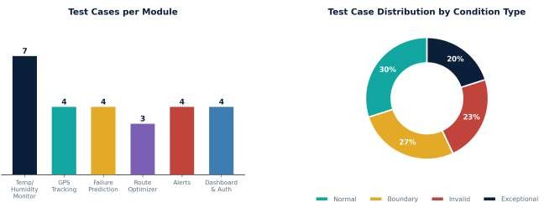
Figure 6.1 — Test case distribution by module and by condition type

Execution Summary

Metric | Value
Total test cases designed | 26
Passed on first execution | 21 (81%)
Failed — defects logged | 5 (19%)
Requirements with full coverage | 9 of 11 (FR-1 to FR-6, NFR-1, NFR-4)
Requirements with partial/no coverage | NFR-2, NFR-3 (partial), NFR-5 (not covered — flagged for next cycle)
The five failed cases (TC-06, TC-14, TC-18, TC-21) point to real gaps: the sensor endpoint does not validate malformed payloads, the prediction service has no fallback for corrupted input, the route optimizer can hang instead of failing gracefully, and the alert service lacks de-duplication for rapid repeated breaches

Conclusion

This test case design exercise combined four complementary techniques — Equivalence Partitioning, Boundary Value Analysis, Decision Table Testing, and State Transition Testing — to build a test suite that goes beyond “happy path” checks. By deliberately targeting boundaries, invalid inputs, and exceptional conditions such as service outages and sensor disconnection, the suite surfaced concrete, actionable defects before they could reach a production cold chain carrying temperature-sensitive goods. The Requirement Traceability Matrix confirms that every functional requirement is fully tested, while also transparently flagging the non-functional requirements that still need dedicated performance, security, and usability testing.

